**CS 328 Final Write-up**

**Environmental tester**

Junqi Zhang, Yudong Diao, Chao Li

**Background**

Due to the fact that most college students don’t have sufficient time for sleep, thus, sleeping quality is very important to us. Our final project’s basic idea is to determine an environment is good for sleep or not.

**Introduction**

In this project what we mainly did is changing the UI and adding a parameter, LUX(unit for light), to test whether the environment is good for sleeping.

First, we created three labels, “Good”, “Very Good” and “Bad”. However, after many demos and tests, we found that most of results don’t fall into the “Very Good” label, therefore we decided to delete “Very Good” label.

**APP UI**

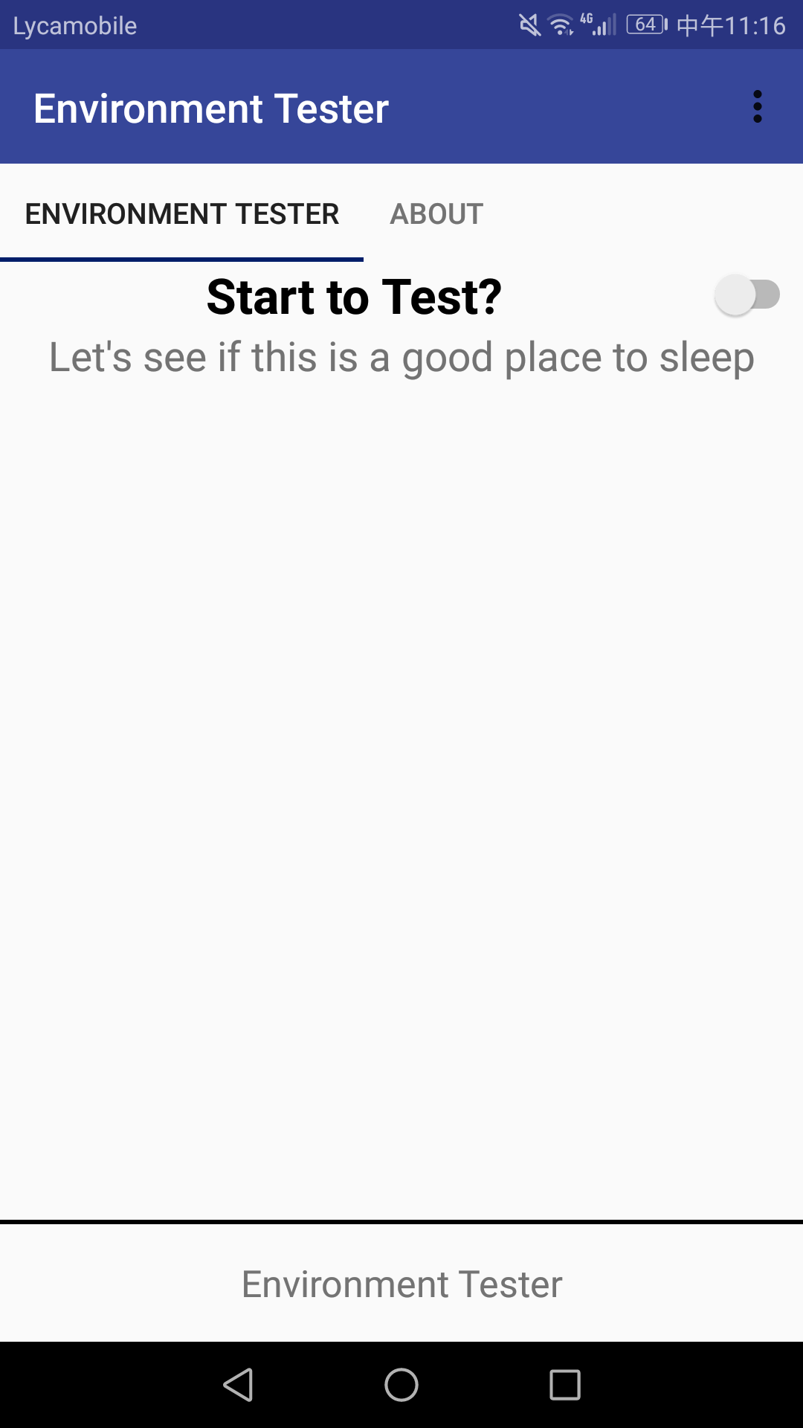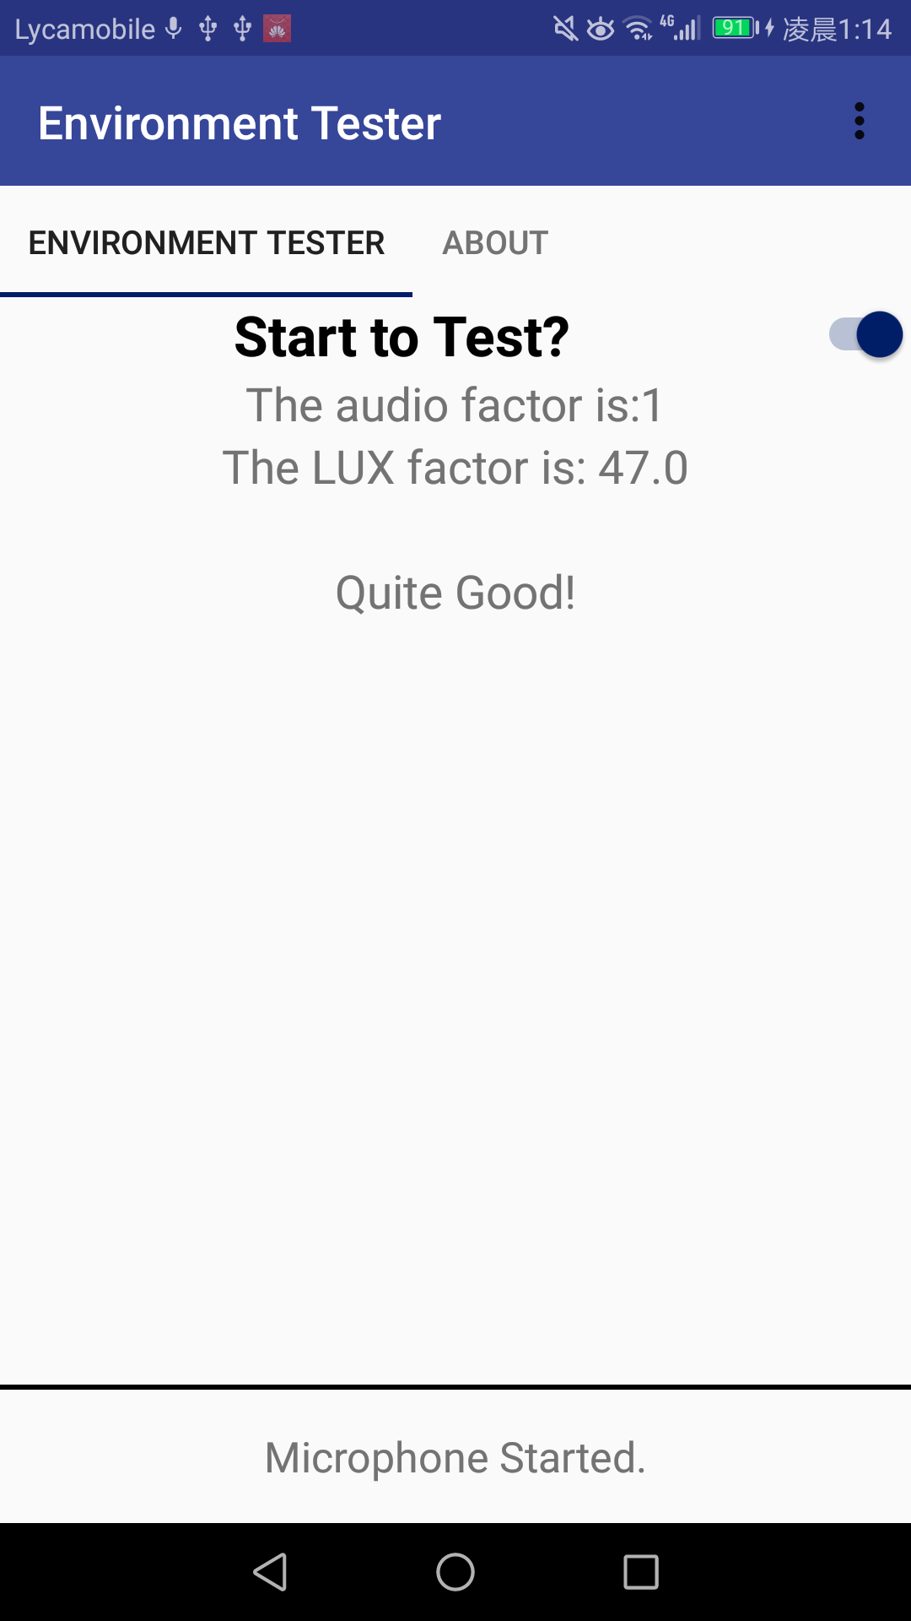

**Algorithm criteria**

result=audio factor*300+LUX data

Audio factor

Range: 0~3

Lux: 0~20000

if(result>1000) then

{

This is for “Bad” environment

}

Else{

This is a “Good” environment

}

**Implementation for LUX data:**

We added a light sensor. Once the data of sensor changed, we send the lux data from MainActivity.java to Constant and then receive it using audiofragment.java.